Table of Contents

INTRODUCTION 1

Scenario 1

Business Rules 2

Information Needs 2

Data Modelling 3

ENTITY-RELATIONSHIP (ER) MODEL 4

Entities & Attributes 4

Relationships 5

Logical Model 6

Relational Model 7

NORMALIZATION 8

Normalization Process 8

Table Creation and Population 13

Creating tables 14

Populating tables 16

Querying Database 19

Security, Integrity, and Ethical Aspects of Data Governance 23

Security 23

Integrity 24

Data Ethics 26

CONCLUSION 27

REFERENCES 28

# INTRODUCTION

## Scenario

This report is based on the design of an information system for an international humanitarian organization, *Aid for All*, which receives donations from donors globally to alleviate specific humanitarian crisis and to provide relief for victims. Donations are made into bank accounts run by the organization. This information system will focus on how donations towards these humanitarian crises are received and managed.

Specifically, this IS will manage information about donations, donors, crises, and receiving bank accounts. This data will provide meaningful insights into the donations received, biodata of donors, humanitarian crises each donation goes to, staff in charge of coordinating efforts to tackle specific crises, bank accounts receiving donations and the staff in charge of managing accounts etc. This will help the organization to perform financial, administrative and operational analysis.

## Business Rules

Specific business rules may be defined as follows:

* Each Donor MUST make one or more donations.
* Each Donor MAY donate towards ANY Crisis.
* Each Crisis may or may NOT receive donations.
* Each Crisis MUST have only one staff assigned as Crisis Coordinator.
* Each Crisis Coordinator MUST be a staff, but not all Staff are Crisis Coordinators.
* Each Crisis Coordinator may coordinate efforts towards tackling one or more Crises.
* Each Donation MUST go into only ONE Account, but it could be ANY of the available Accounts.
* Each Account may or may NOT receive donations.
* Each Account MUST have only one staff assigned as account manager.
* Each account manager MUST be a staff, but not all Staff are account managers.
* Each account manager may manage one or more bank accounts.

## Information Needs

Several levels of information are required by internal and external stakeholders in the organization for several purposes.

### *Operational*

* Donors need to know which crises they can donate to.
* Donors need information of the accounts they can donate into.
* The organization needs information on donations to each crisis it seeks to alleviate, in order to plan its activities.
* The organization needs biodata of donors to inform fundraising strategies i.e., to know which demographics to target generally, and/or according to each crisis.

### *Administrative*

* The organization needs information of donors and their donations for reference purposes.
* The organization needs information of accounts and staff in charge of account management.
* The organization needs information of crises and staff in charge of crisis coordination.
* The organization needs information about staff and volunteers.

### *Accounting & Budgeting*

* The organization needs information of funds received in each account for financial analysis and budgeting purposes.
* The organization needs information on disbursement of funds from these accounts to each crisis.

## Data Modelling

This information system is designed to accommodate the information needs of all stakeholders of the organization by the provision of relevant data. In order to meet these needs, the relevant entities containing the required data attributes are modelled as:

1. Donation: this entity provides information about each donation the organization receives. Attributes include **donationID** (donation unique identifier/primary key), **donationDate** (date of donation), **donationAmount** (donation amount), **donorID** (donor unique identifier), **crisisID** (crisis unique identifier), **accountID** (account unique identifier).
2. Donor: This provides donor biodata. Attributes include **donorID** (donor unique identifier/primary key), **donorName** (donor’s full name), **donorGender** (donor’s gender), **donorLocation** (donor’s country), **donorJobfield** (donor’s jobfield).
3. Crisis: this entity provides information on the several humanitarian crises the organization aims to tackle or alleviate. Attributes include **crisisID** (crisis unique identifier), **crisis** (the specific crisis donations are made towards), **crisisLocation**(location of specific crisis), **crisisCoordinatorID** (unique identifier for staff in charge of managing and coordinating activities against each crisis).
4. Account: This entity provides information about bank accounts which donations can be made into. Attributes include **accountID** (the bank account the donation was sent into), **bankName** (name of the bank where account belongs), **accountName** (name which the account bears), **accountManagerID** (unique identifier for staff in charge of managing the account/account manager.
5. Staff: This entity provides information about members of staff and volunteers. Attributes include **staffID** (staff unique identifier), **staffName** (Name of staff), **staffRole** (the position the staff occupies within the organization), **staffSalary** (salary received by each staff).

# ENTITY-RELATIONSHIP (ER) MODEL

An Entity-Relationship model is a diagram which explains the logical structure of a database. The ER model displays the relationship between entities in a database. The main components of an ER model are Entities, Relationships, and Attributes.

## Entities & Attributes

Entities of the database have been defined as follows (with primary key attributes underlined):

1. Donation: **(donationID**, **donationDate**, **donationAmount**, **donorID**, **crisisID**, **accountID)**

* *Foreign key(s):* ***donorID****,* ***crisisID****,* ***accountID***

1. Donor: (**donorID** , **donorName**, **donorGender**, **donorLocation**, **donorJobfield)**
2. Crisis: (**crisisID**, **crisis**, **crisisLocation**, **crisisCoordinatorID)**

* *Foreign key(s):* ***crisisCoordinatorID***

1. Account: (**accountID**, **bankName**, **accountName,** **accountManagerID)**

* *Foreign key(s):* ***accountManagerID***

1. Staff: **staffID**, **staffName**, **staffRole**, **staffSalary**

## Relationships

These are associations between two or more entities of a database. The following relationships are defined for this database:

1. Donor and Donation

* *Relationship*: Donor (1 .. 1) **makes** Donation (1 ..*)

Each Donor makes one or more Donations. Each Donation comes from one and only Donor.

* *Cardinality*: One-to-Many (1:N)
* *Participation*: Source & Target Mandatory

1. Donation and Account

* *Relationship*: Account (0..*) **is credited with** Donation (1 …1)

*Each Donation is deposited into one and only one Account. Each Account receives zero to many Donations.*

* *Cardinality*: One-to-many (1:N)
* *Participation*: Source Optional, Target Mandatory

1. Donation and Crisis

* Relationship: Crisis (0..*) **receives** (1…1) Donation (1 .. 1)

*Each Donation is made towards tackling a Crisis. Each Crisis receives zero to many Donations.*

* *Cardinality*: One-to-many (1:N)
* *Participation*: Source Optional, Target Mandatory

1. Staff and Account

* Relationship: Staff (1 .. 1) **manages** (0…*) Account

*Each Account is managed by a Staff. Each staff manages zero to many Accounts.*

* *Cardinality*: One-to-many (1:N)
* *Participation*: Source Optional, Target Mandatory

1. Staff and Crisis

* Relationship: Staff (1..1) **coordinates** (0…*) Crisis.

*Each Crisis is coordinated by a Staff. Each staff coordinates zero to many Accounts.*

* *Cardinality*: One-to-many (1:N)
* *Participation*: Source Optional, Target Mandatory

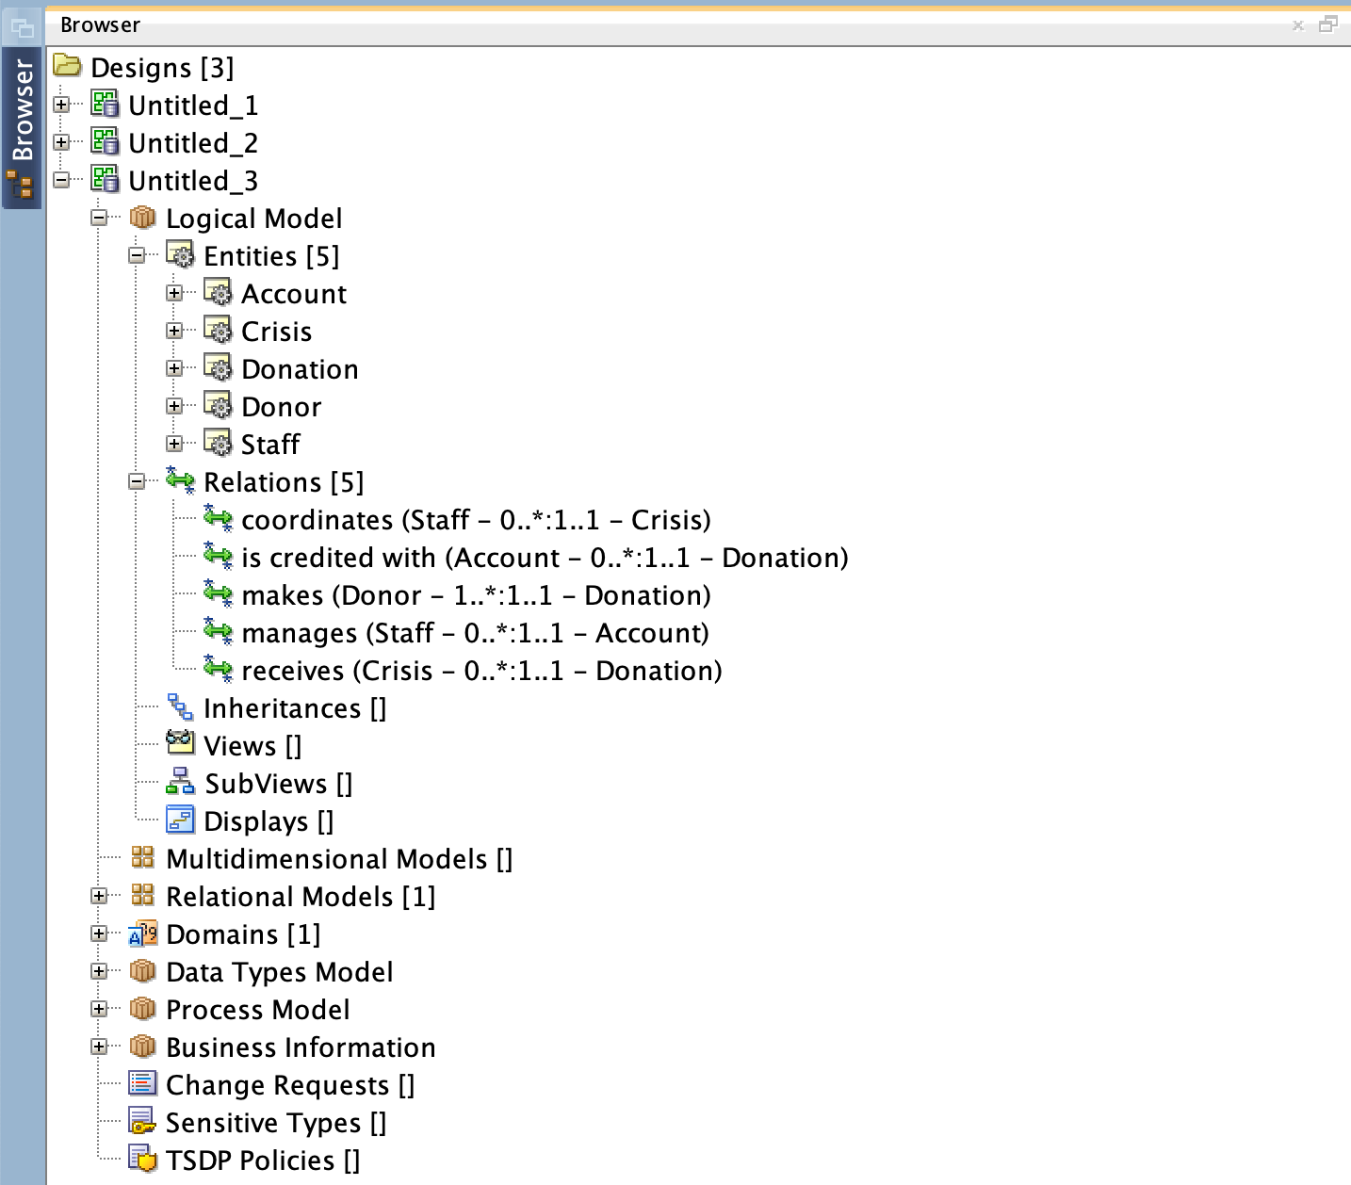

Figure 1: Entity relationship definitions showing multiplicity constraints

## Logical Model

A logical model is built using Oracle SQL Data Modeller by defining entities, attributes, and the relationship between attributes. Figure 1 shows this step and Figure 2 shows logical model.

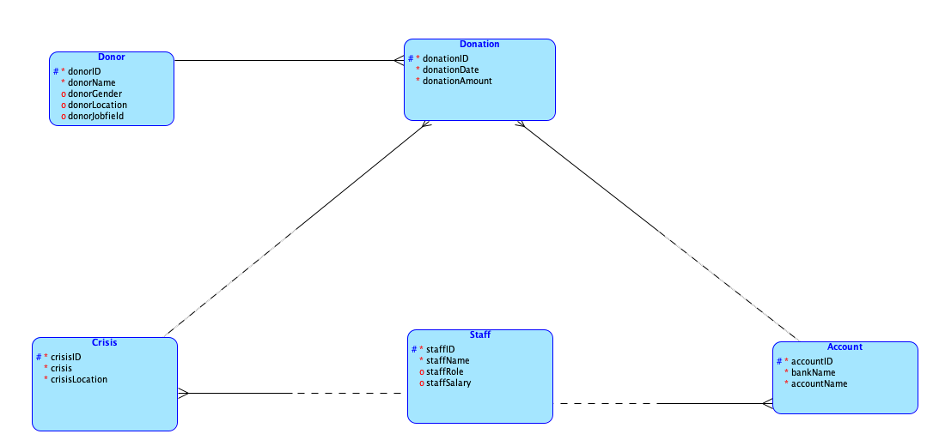

Figure 2: Logical ER Model

## Relational Model

Oracle SQL Data Modeller automatically engineers a relational model based on relations defined in logical model. Figure 3 shows relational model.

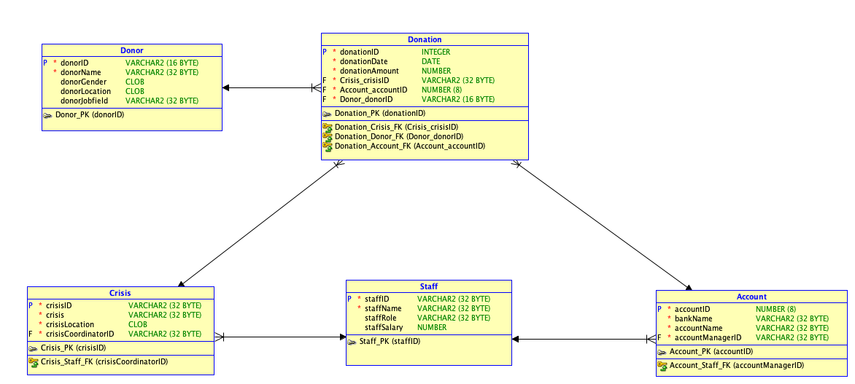

Figure 3: Relational ER Model

# NORMALIZATION

Normalization is a technique for producing a set of relations with desirable properties, given the data requirements of an organization. Normalization removes data redundancy, and eliminates Insert, Update, and Deletion Anomalies.

Figure 4 shows a dummy dataset for Donor donations in Unnormalized form (UNF). I would attempt to normalize this relation to 3NF.

## Normalization Process

The following describe steps taken to normalize my dataset from UNF to 3NF in relation to *Aid for All*’s information system:

1. Unnormalized Form (UNF): This means that our table contains repeating groups i.e., there is more than one value at the intersection of each row and column. Figure 4 below shows that my dummy data is currently unnormalized because it contains repeating groups for a single occurrence of the nominated key attribute (**donorID**) for that table.To put this in context, donors with more than one donation have repeating groups for each value of their donation attributes (**donationID,** **donationDate, donationAmount,** **crisisID, crisis, crisisLocation, crisisCoordinatorID, crisisCoordinatorName, accountID, bankName, accountName, accountManagerID, accountManagerName)**. I eliminate this by duplicating values for donor information for each repeating group. The ensuing data table is shown in Figure 5. Upon further analysis of the ensuing relation, it would make more logical sense to identify **donationID** as the key attribute because it fully functionally determines every attribute in the relation. I will call this relation (entity) **Donation**.



Figure 4: UNF Donor donations data table

1. First Normal Form (1NF): This means that the table does not repeating groups. This is demonstrated in Figure 5 below. The relation, **Donation**, contains data describing each **donationID**, the date and amount of donation, name, gender, location and jobfield of the donor, the crisis the donation is meant for, including details of the crisis, location, and crisis coordinator. It also contains data describing the account which the donation was deposited, the name of the bank, the account name, and name and ID of the staff managing the account.



Figure 5: 2NF Donation data table

1. Second Normal Form (2NF): For a table to be in 2NF, the table must be in 1NF and contain no partial dependencies. Partial dependencies can only exist in a relation with a composite primary key i.e., a primary key with a combination of more than one key attribute. This means that any relation having a primary key of a single attribute automatically gets to its 2NF. To identify partial dependencies, I must first define functional dependency for the **Donation** relation.

*Functional dependency*: **donationID**  **donationDate, donationAmount, donorID, donorGender, donorLocation, donorJobfield, crisisID, crisis, crisisLocation, crisisCoordinatorID, crisisCoordinatorName, accountID, bankName, accountName, accountManagerID, accountManagerName**

The primary key for the table is **donationID**,as it fully functionally determines every other attribute. There is a one-to-one relationship between **donationID**, and attributes on the right-hand side of the functional dependency. This holds for all time and the determinant has the minimal number of attributes necessary to maintain full functional dependency with the attributes on the right side.

Hence, my **Donation** relation is already in 2NF because there are no partial dependencies.

1. Third Normal Form (3NF): A relation is said to be in 3NF when it is in 2NF and no transitive dependency exists for non-prime attributes. Transitive dependency occurs when some non-prime attribute determines some other attribute. Transitive dependencies which exist in the 2NF **Donation** relation are as follows:

TD1: **donorID donorName, donorGender,donorLocation, donorJobfield**

TD2: **crisisID crisis, crisisLocation, crisisCoordinatorID, crisisCoordinatorName**

TD3: **accountID bankName, accountName, accountManagerID, accountManagerName**

To eliminate these transitive dependencies from the **Donation** relation, transitively dependent attributes must be removed from the relation. This is done by creating new relations for these attributes along with the determinant attributes. The determinant attributes then become foreign keys in the **Donation** relation. TD1, TD2 & TD3 would be used to create **Donor**, **Crisis**, and **Account** entities respectively.

It is observed that TD2 and TD3 contain transitive dependencies:

TD4: **crisisCoordinatorID** **crisisCoordinatorName**

TD5: **accountManagerID** **accountMangerName**

This means that **Crisis** and **Account** relations are in 2NF. To bring to 3NF, I eliminate these transitive dependencies, then create a **Staff** relation since crisis coordinator and account manager are members of staff of the organization. Upon doing this, the database and its individual relations are in 3NF as shown in the figures below.



Figure 6:3NF Donation table



Figure 7: 3NF Donor table



Figure 8: 3NF Crisis table



Figure 9: 3NF Account table



Figure 10: 3NF Staff table

[Dummy Data](https://1drv.ms/x/s!AktWDBAgkRMwgSkU83-WeqkmLQZb) shows the relations at each step of the normalization process (i.e., 3NF, 2NF, 1NF, UNF) for better readability.

# Table Creation and Population

The database schema is created and populated using PostgreSQL (PgAdmin4) as shown in Figure 11 below. Five tables were created for Donor, Donation, Crisis, Staff, and Account. The SQL statements used in creating, altering, and populating these tables are shown in the following sections.

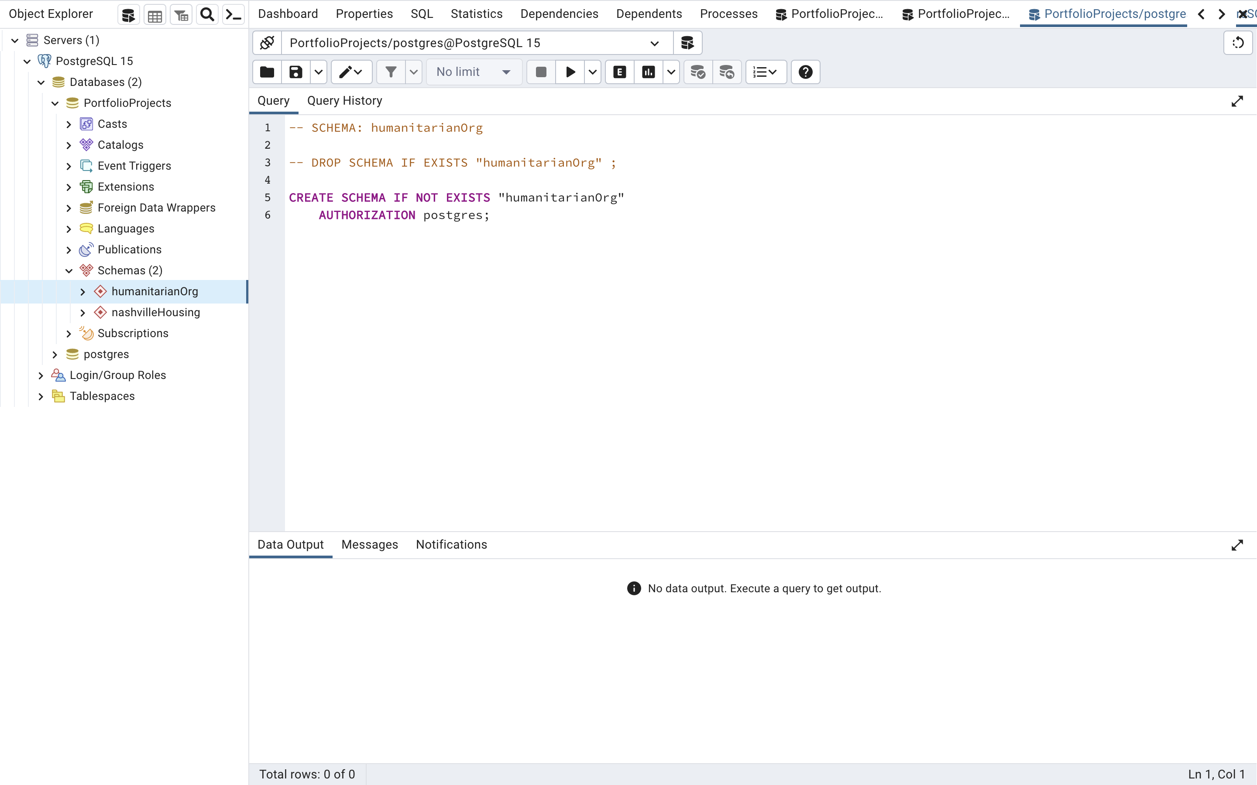

Figure 11: CREATE SCHEMA statement.

## 

## Creating tables

The account, donor, donation, crisis, and staff tables respectively are created using CREATE TABLE statements, as demonstrated in the figures below.

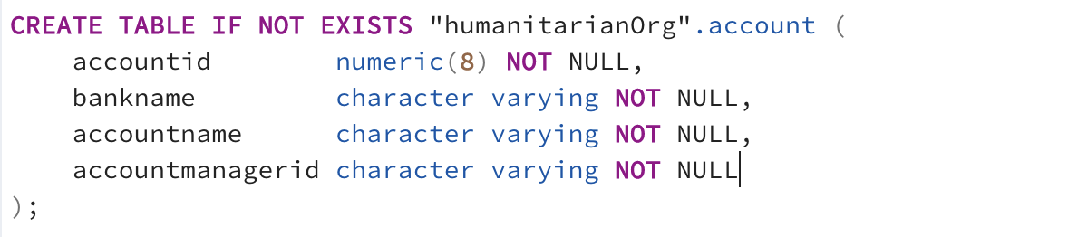

Figure 12: CREATE TABLE account statement.

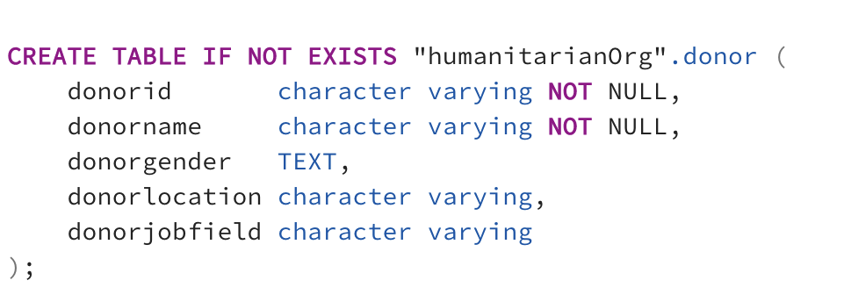

Figure 13: CREATE TABLE donor statement.

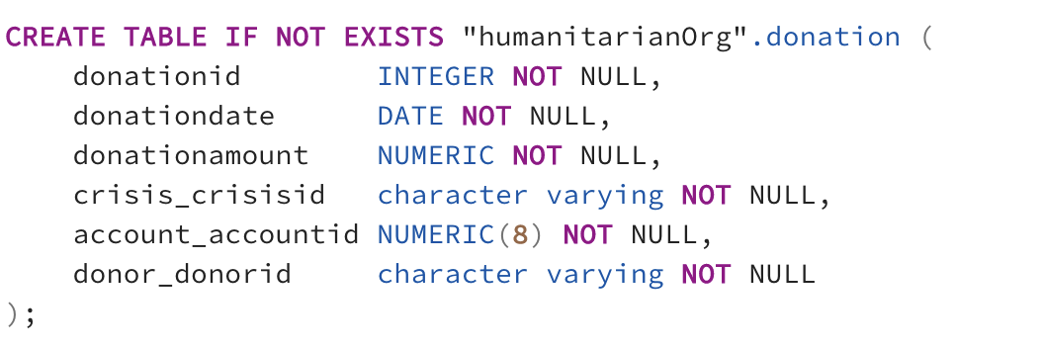

Figure 14: CREATE TABLE donation statement.

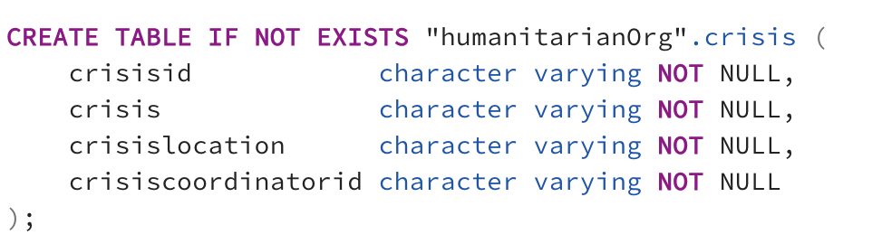

Figure 15: CREATE TABLE crisis statement.

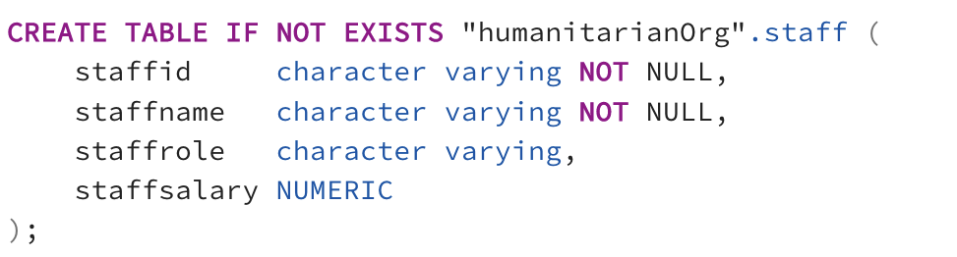

Figure 16: CREATE TABLE staff statement.

## Populating tables

Mock values are inserted into the account, donation, donor, crisis, and staff tables respectively using INSERT statements, as demonstrated in the figures below.

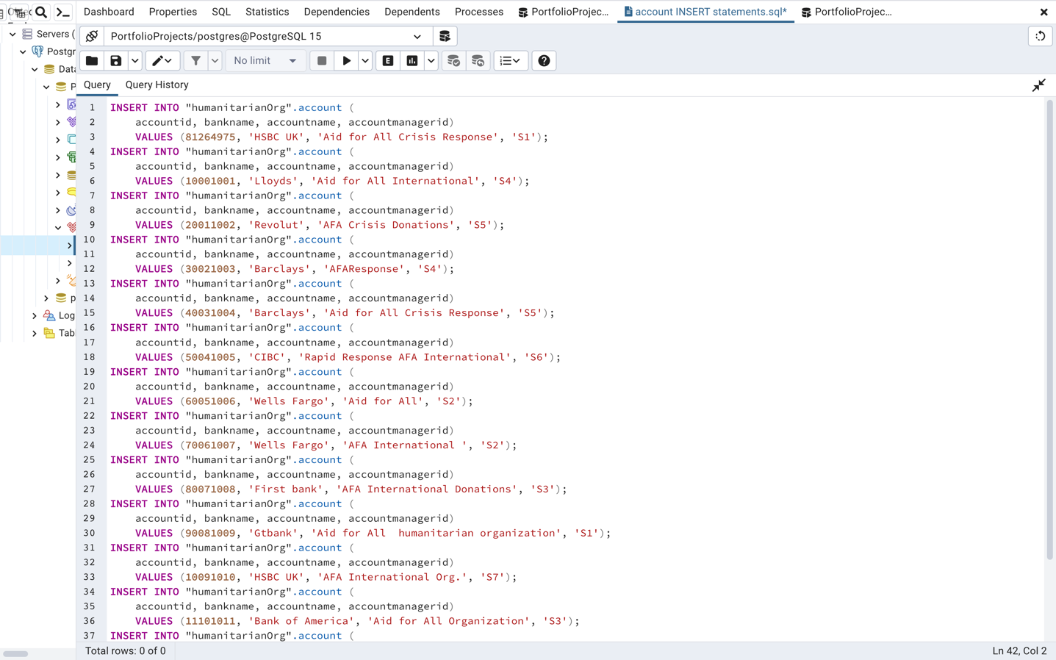

Figure 17: INSERT INTO account.

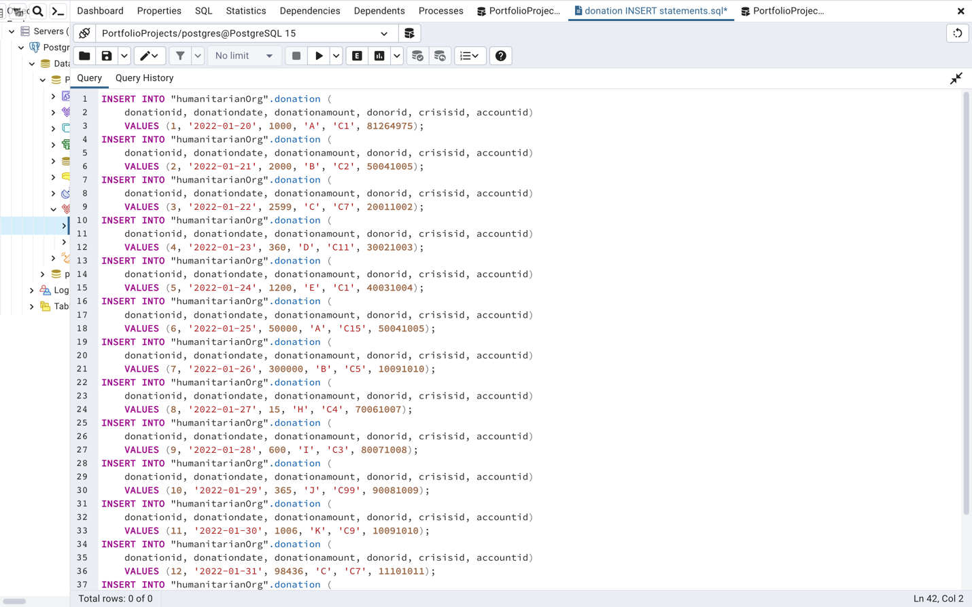

Figure 18: INSERT INTO donation.

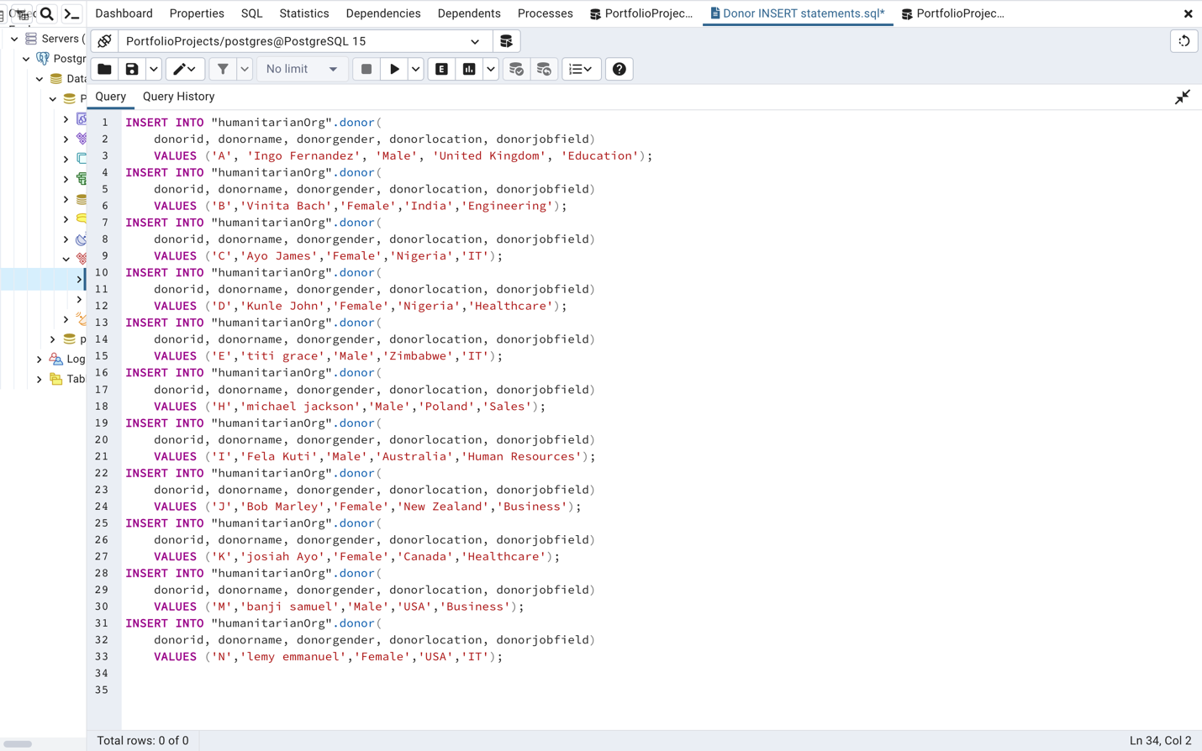

Figure 19: INSERT INTO donor.

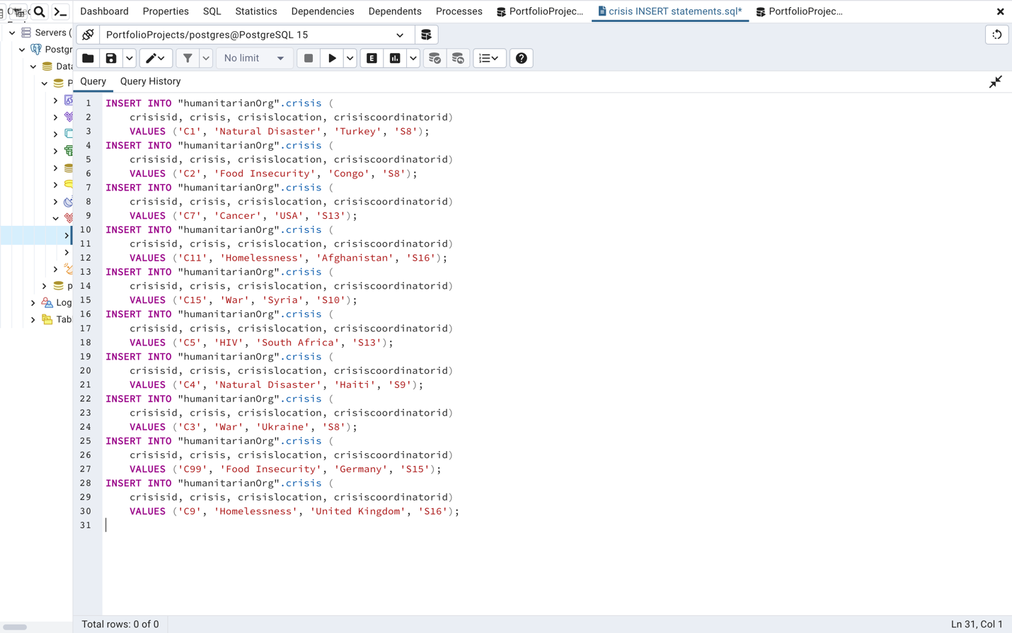

Figure 20: INSERT INTO crisis.

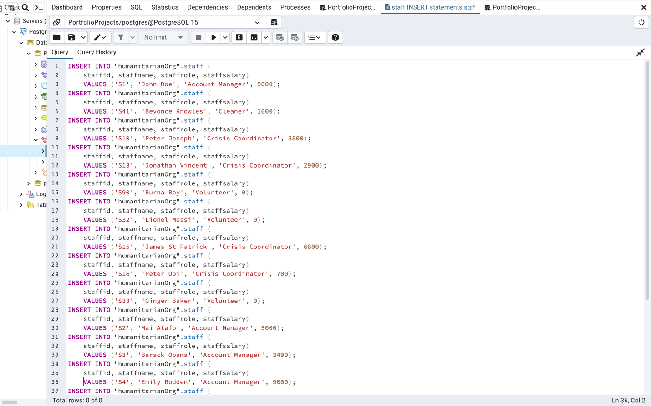

Figure 21: INSERT INTO staff.

# Querying Database

Query 1: The query below selects total donation amount of each donor.

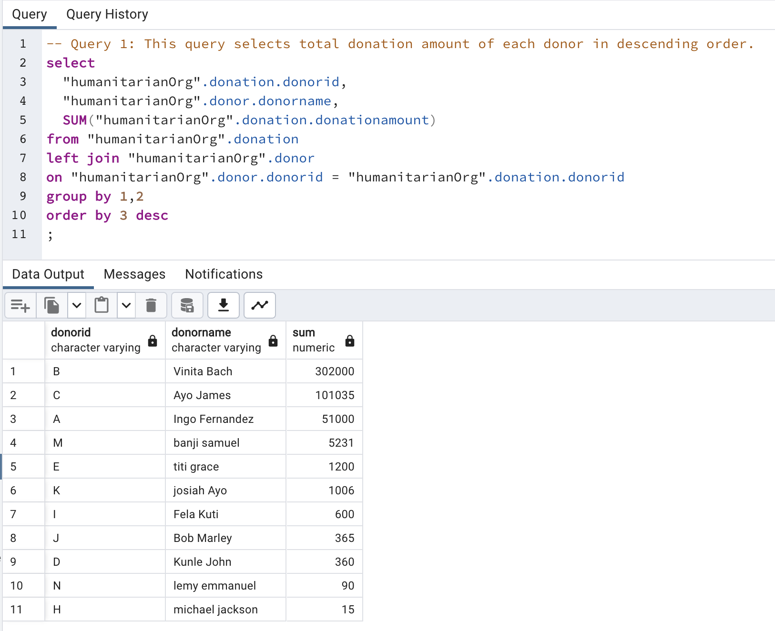

Figure 22: Donation amount by Donor

Query 2: The query below selects total donation amount received by each crisis.

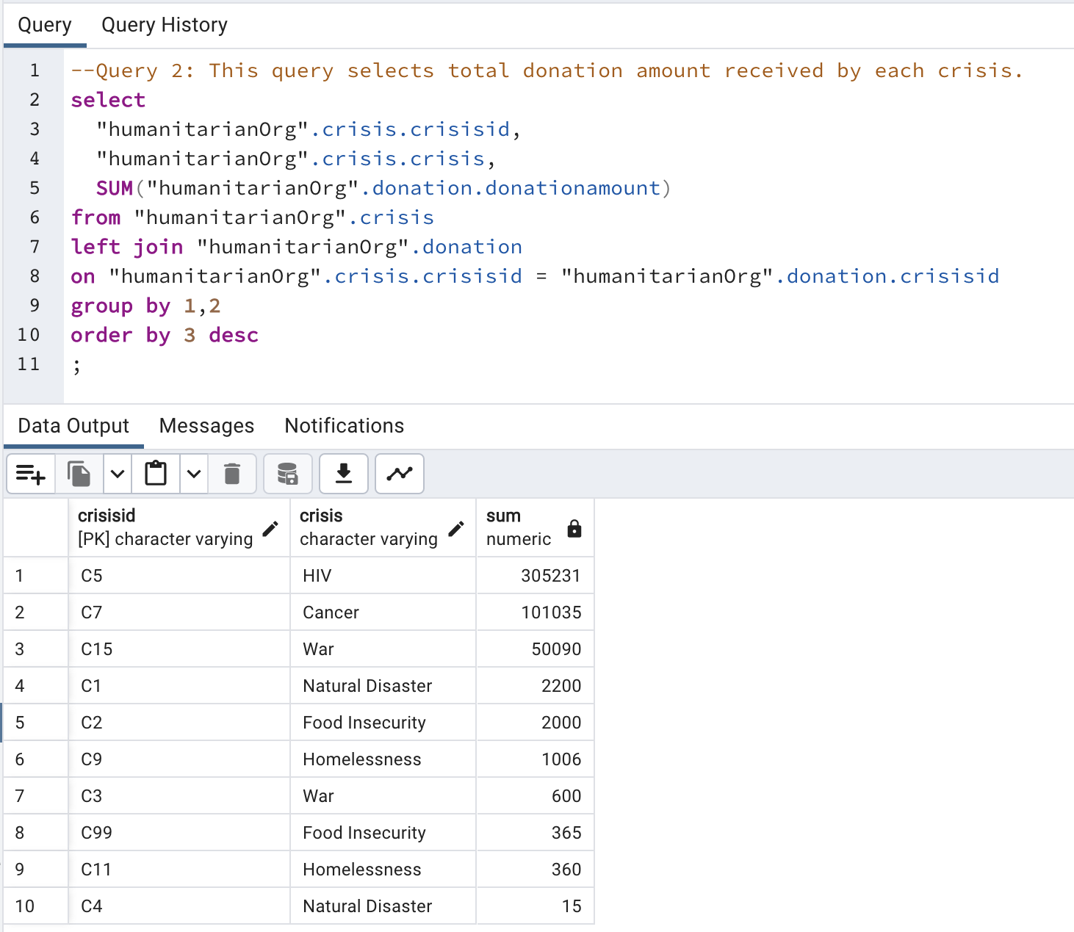

Figure 23: Donation amount by Crisis

Query 3: The query below selects each account and number of donations received.

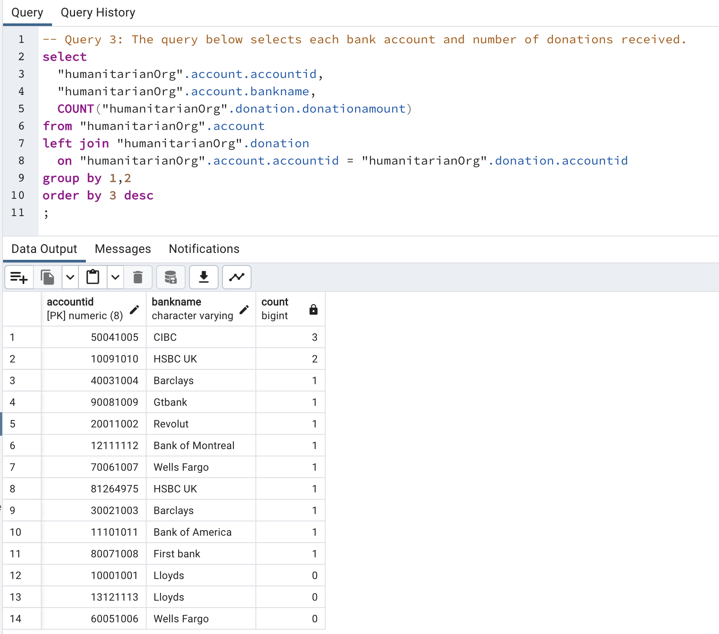

Figure 24: Count of donations received by each account.

Query 4: The query below selects total salary grouped by staff role.

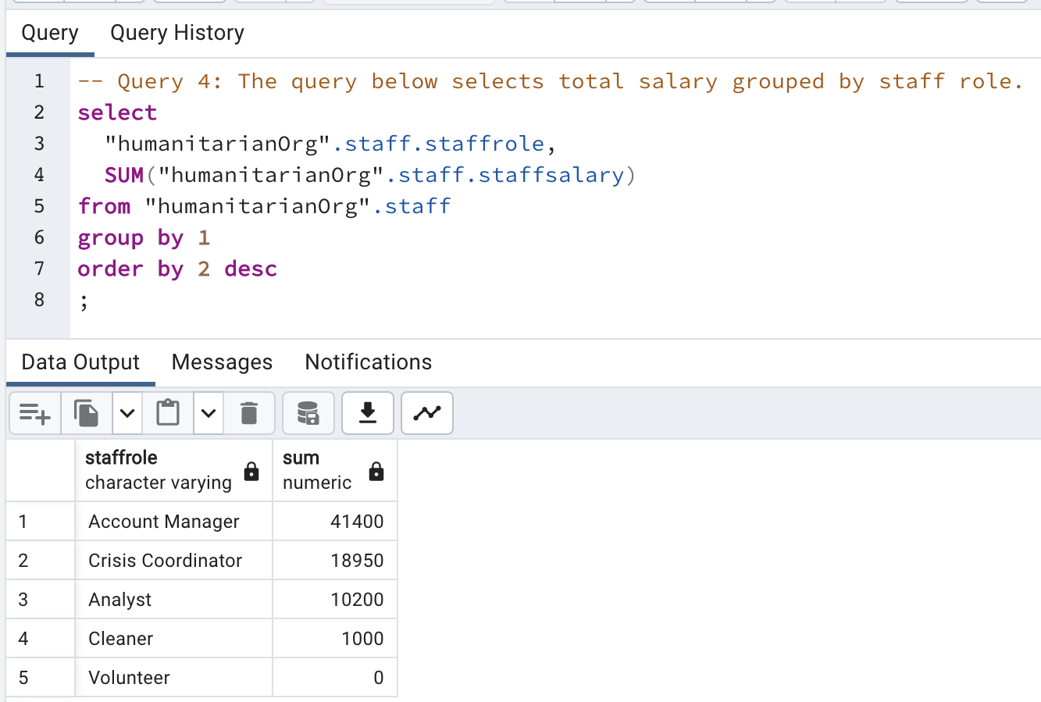

Figure 25: Salary by staff role query.

Query 5: The query below shows total donations received.

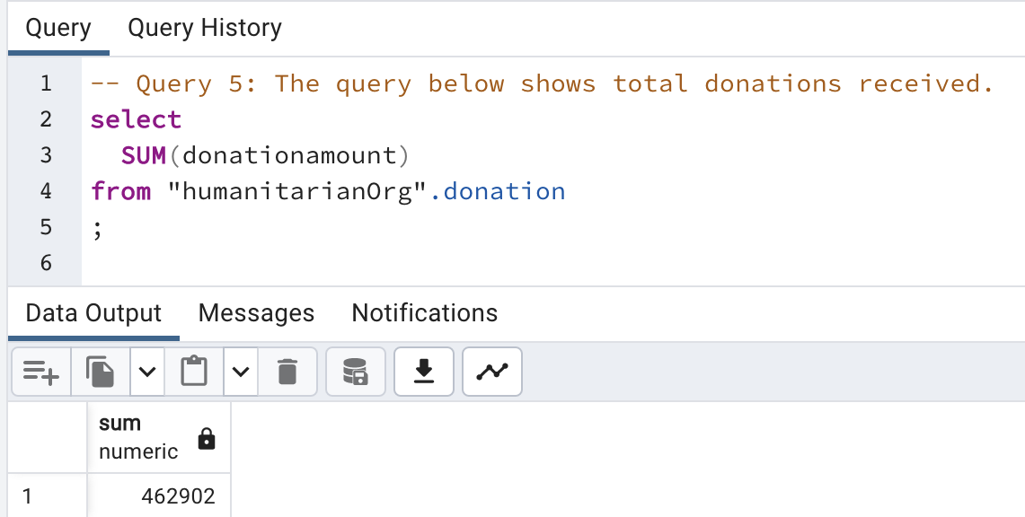

Figure 26: Total donation amount received query.

# Security, Integrity, and Ethical Aspects of Data Governance

Security

Data security is critical for humanitarian organizations, which may deal with sensitive personal information such as personal identification information, and data related to communities in conflict or disaster situations. The organization should have a clear policy regarding data access and should ensure that staff members are trained in secure data handling practices.

The following are some ways to ensure data security in a humanitarian organization's database:

* **Use strong passwords**: Require strong passwords that include a mix of letters, numbers, and special characters. Implement policies for password expiration and complexity.
* **Access control**: Limit access to sensitive data to authorized personnel only. Implement access control policies to ensure that only those who need to access specific data can do so.
* **Encryption**: Use encryption to protect sensitive data both in transit and at rest. This includes data in databases, backups, and archives.
* **Regular backups**: Regularly back up data to ensure that it can be restored in case of a security breach or system failure.

Here is an example of SQL code that can be used to set up access control policies for the donor table:

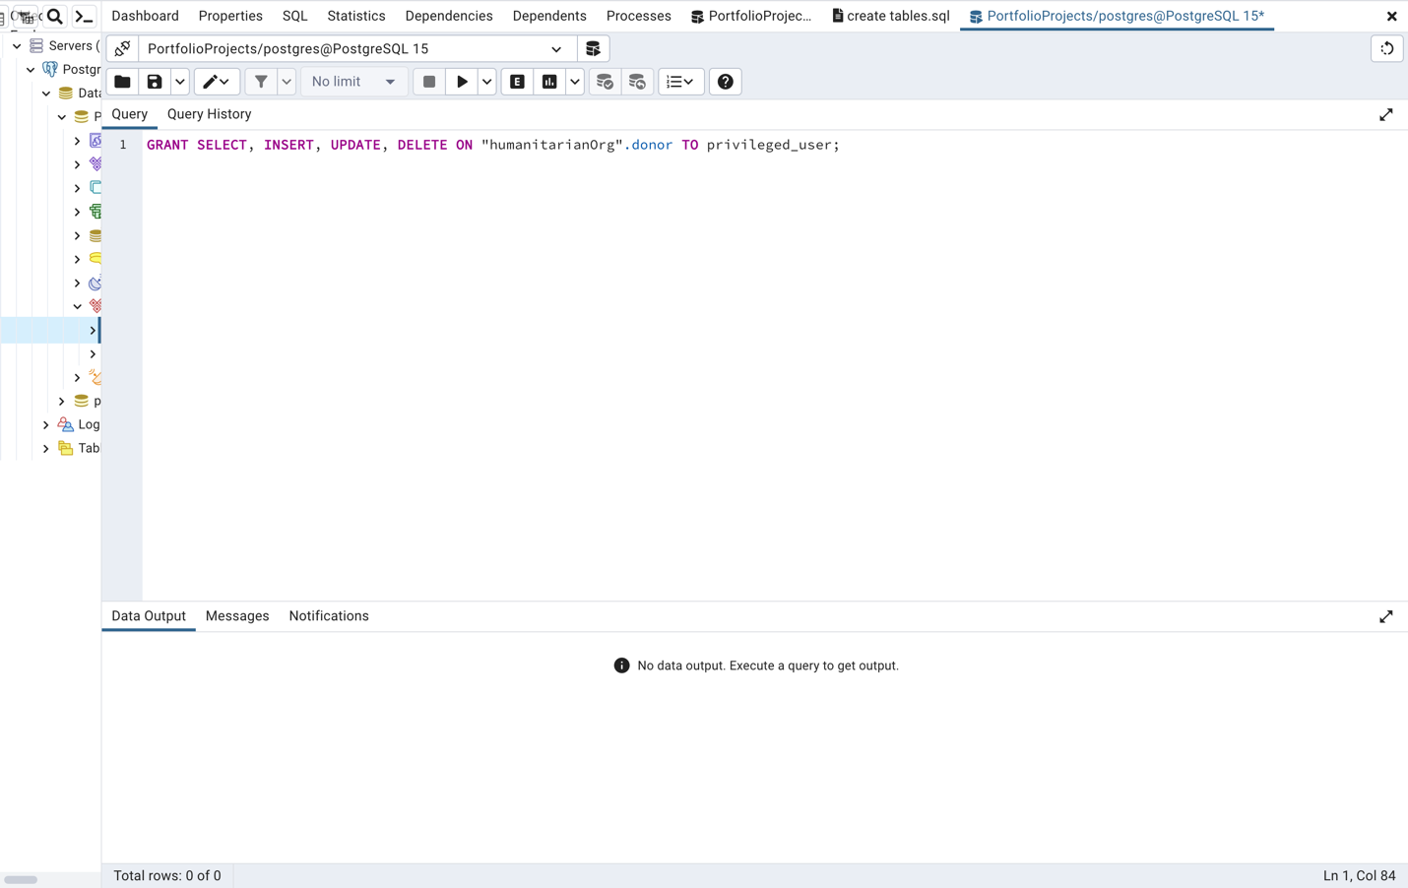

Figure 27: GRANT statement for access control.

This code grants privileges to a user called privileged user, allowing them to select, insert, update, and delete data from the donor table.

## Integrity

Data in a humanitarian organization's database should be reliable, and there should be no chance of losing it or altering it unintentionally.

Data integrity is made up of the following parts:

* **Entity integrity**

To identify each row in a table, the table must have a primary key. The primary key is a unique value that identifies each row. This requirement is called the entity integrity constraint.

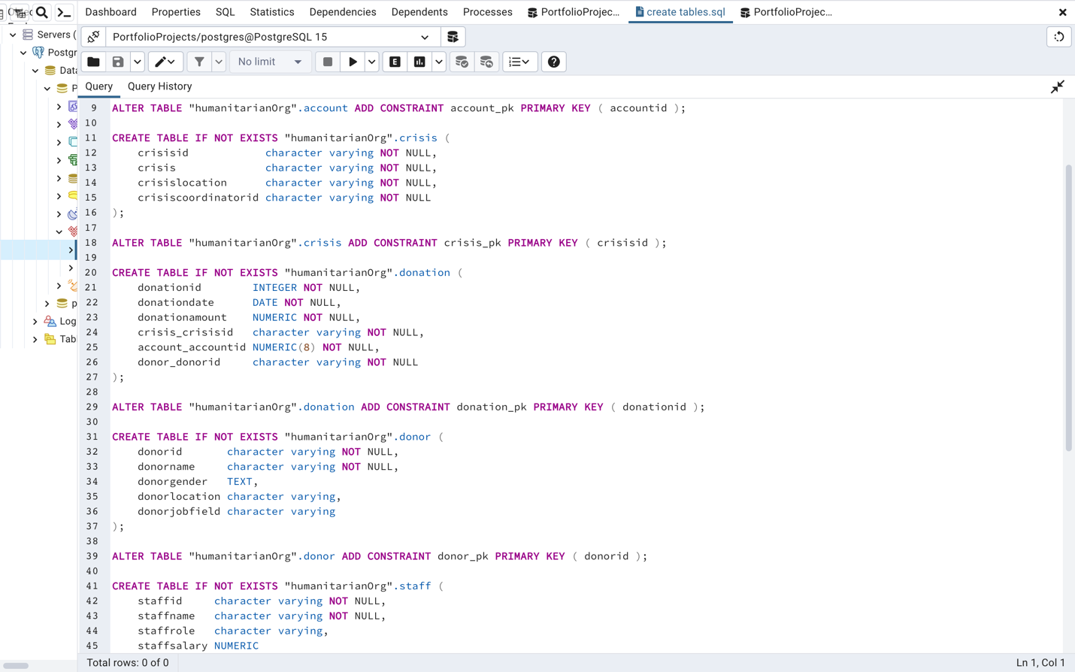

Figure 28: account entity constraint

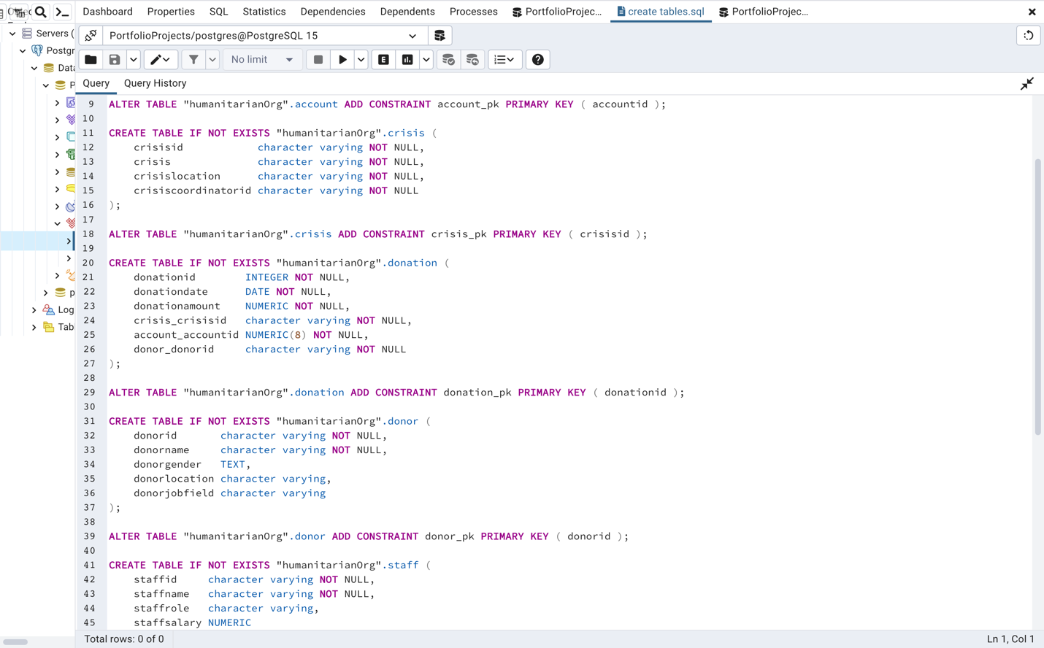

Figure 29: crisis entity constraint

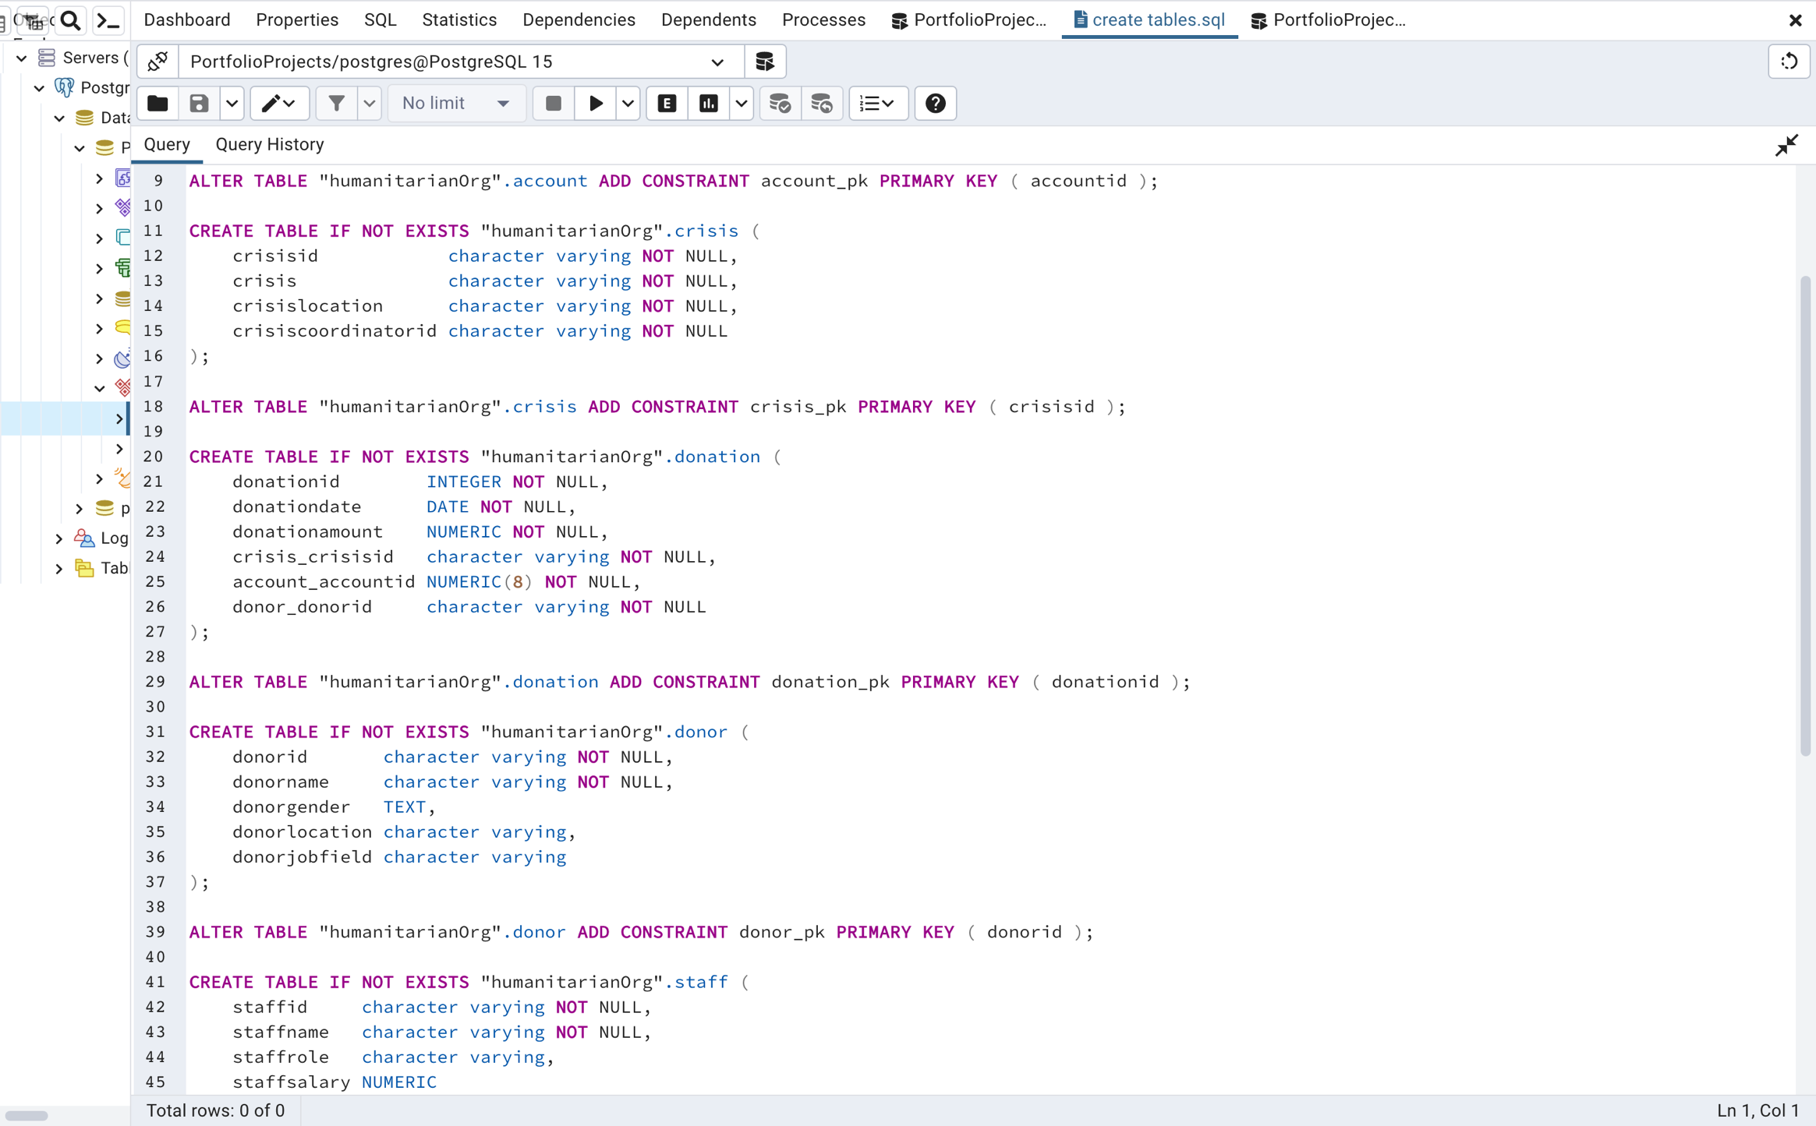

Figure 30: donation entity constraint

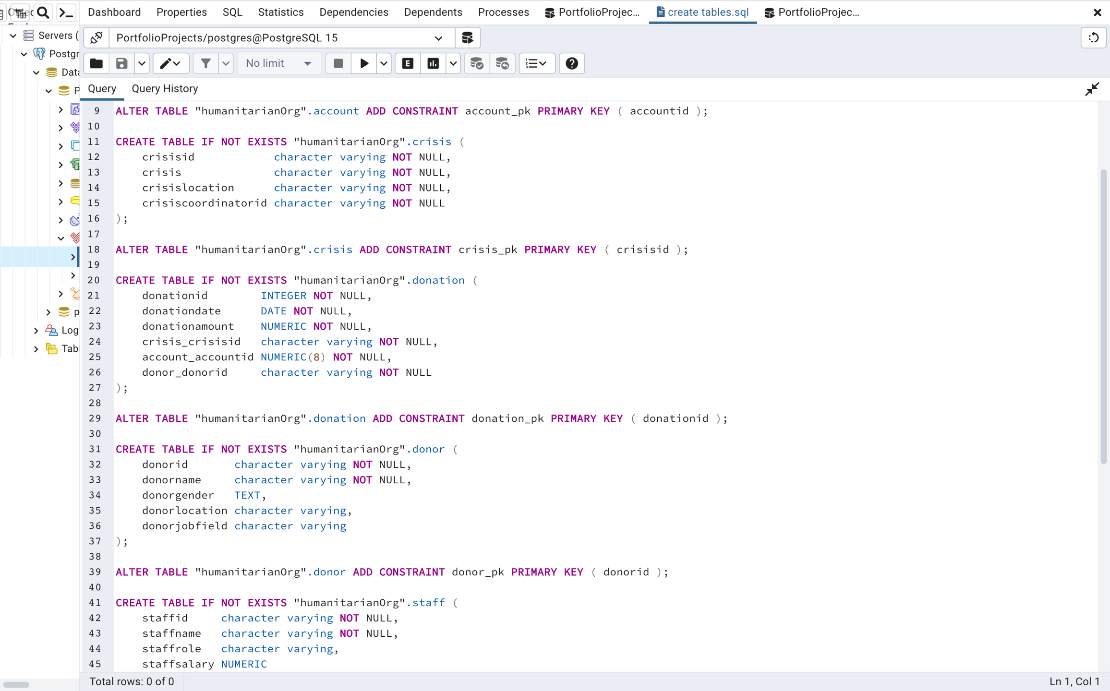

Figure 31:donor entity constraint

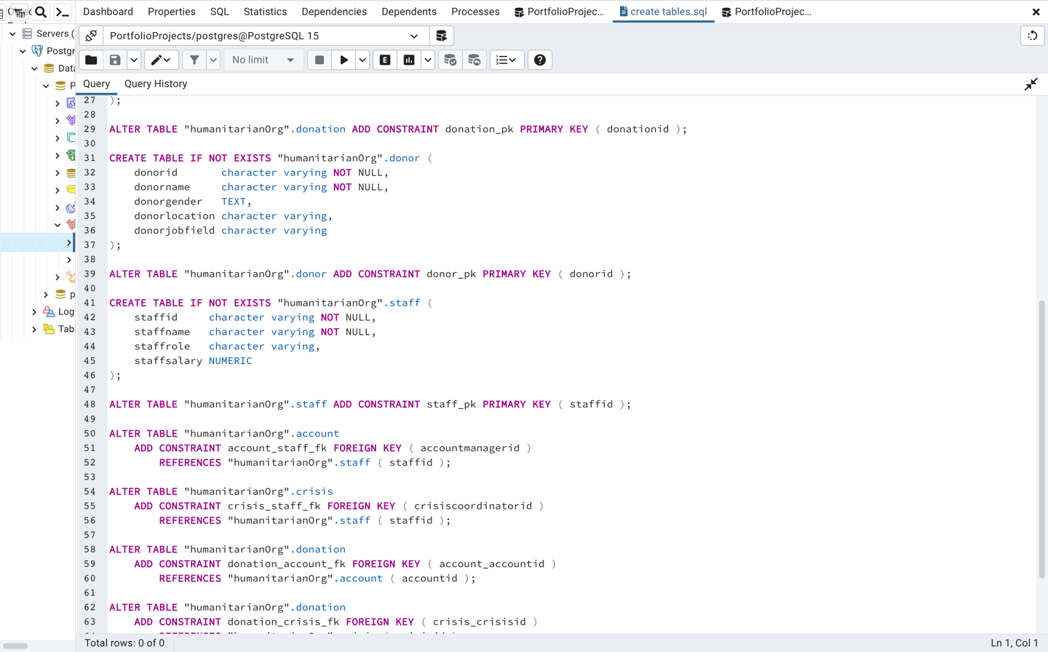

Figure 32: staff entity constraint

* **Semantic integrity**

Semantic integrity ensures that data entered into a row reflects an allowable value for that row. The value must be within the domain, or allowable set of values, for that column. For example, the ACCOUNTID column of the **account** table permits only 8-digit numbers. If a value outside the domain is entered into a column, the semantic integrity of the data is violated.

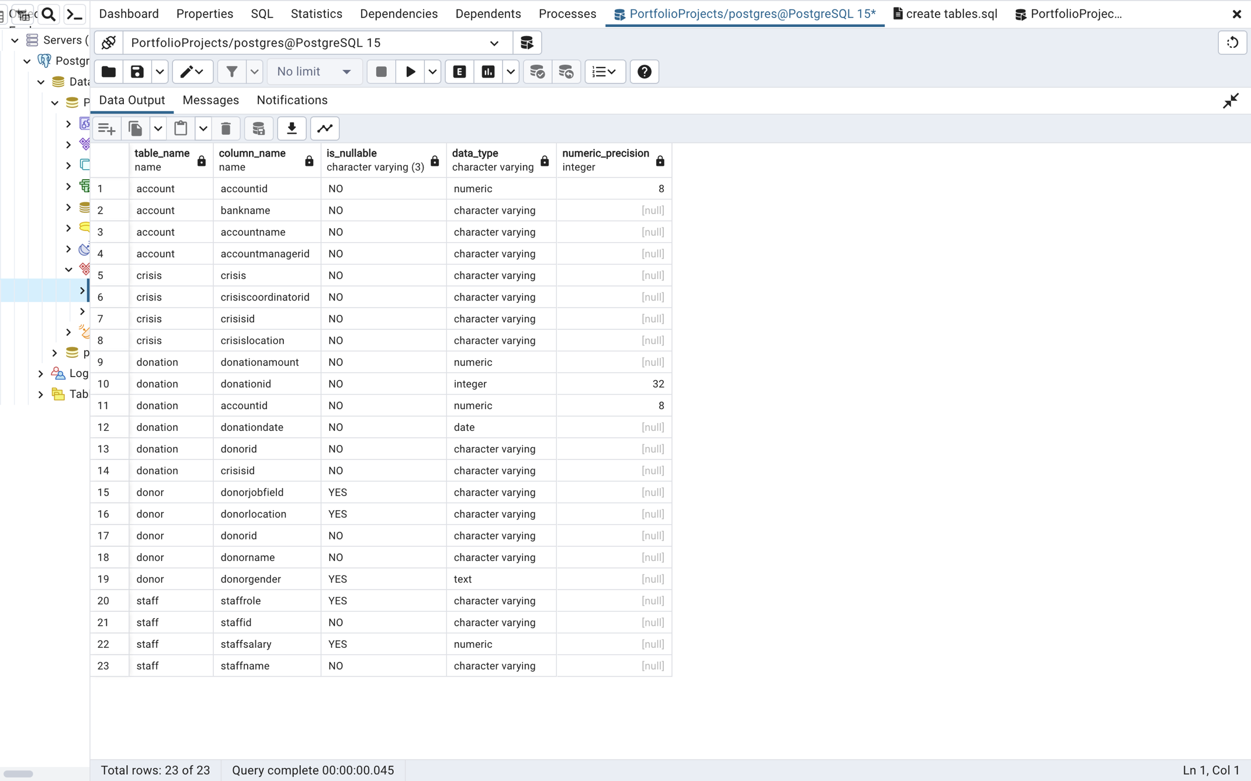

Figure 33: Semantic Integrity constraints

* **Referential integrity**

Referential integrity refers to the logical dependency of a foreign key on a primary key. The integrity of a row containing a foreign key depends on the integrity of the row it references i.e., the row containing the matching primary key.

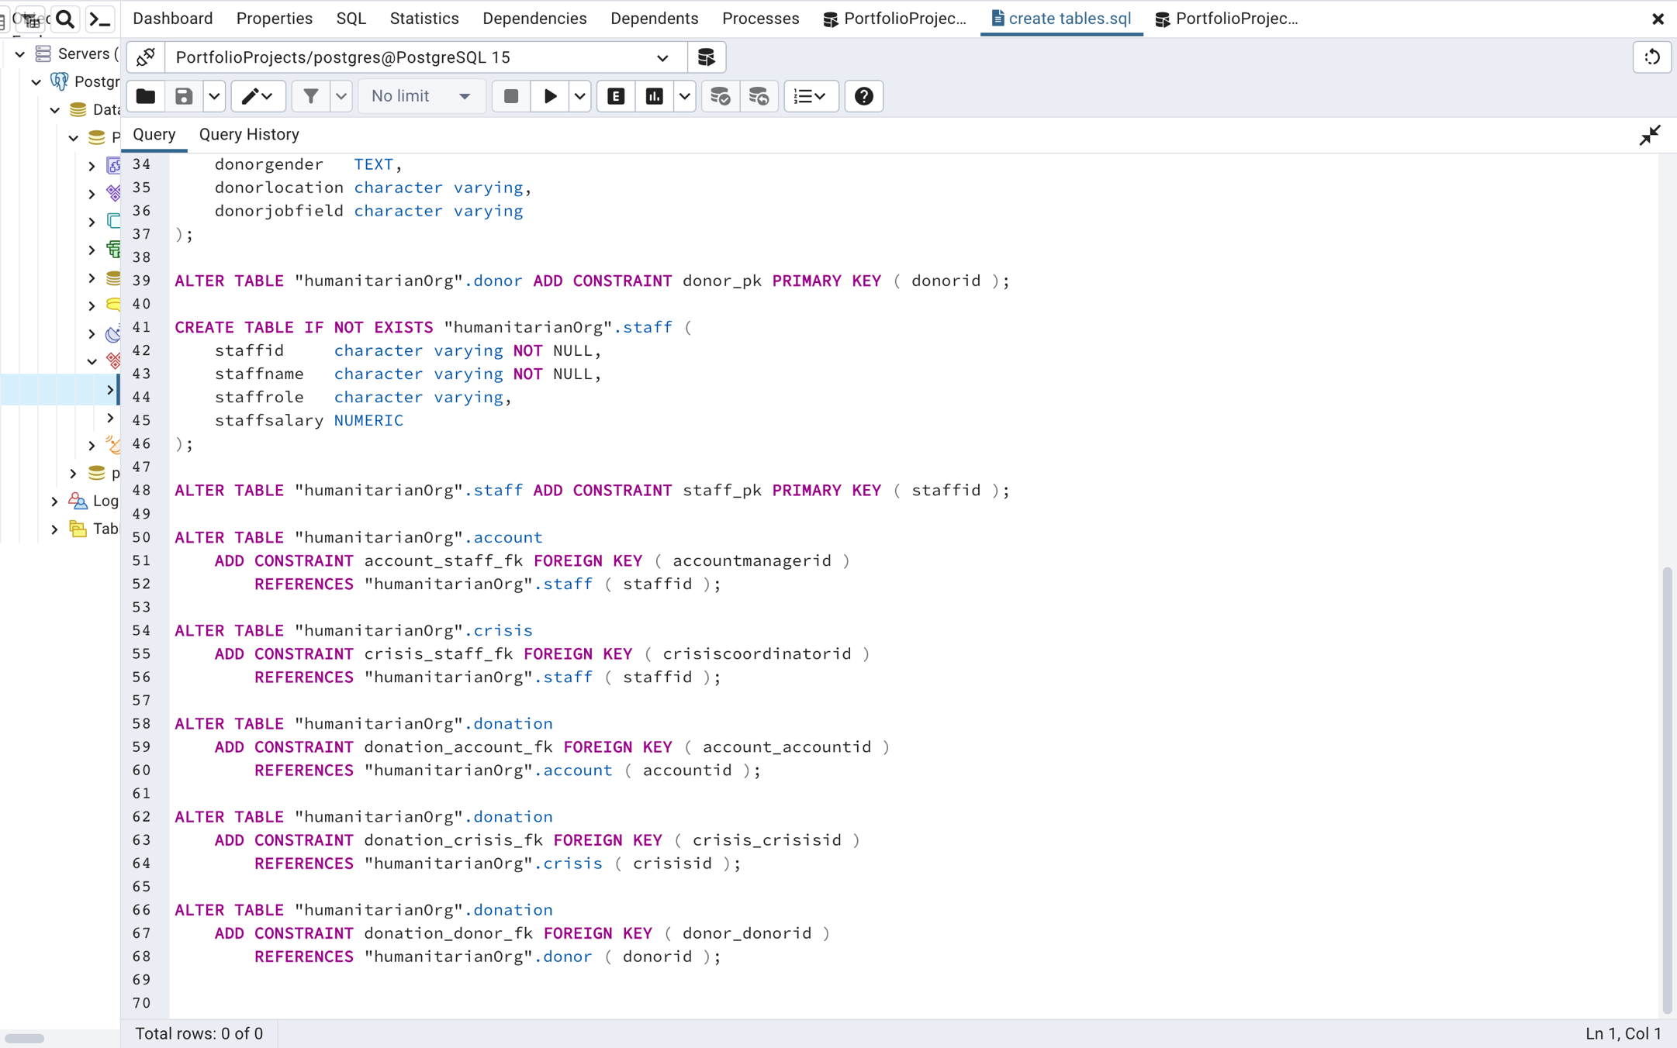

Figure 34: Referential Integrity constraints.

## Data Ethics

organizations need to ensure that they are using data in ways that are consistent with their mission and values. Here are some ways to ensure ethical data use:

* **Privacy policies**: Create clear and concise privacy policies that explain how data is collected, stored, and used.
* **Data anonymization**: Remove personally identifiable information from datasets to protect the privacy of individuals.
* **Informed consent**: Obtain informed consent from individuals before collecting their data.
* **Data transparency**: Be transparent about how data is collected, used, and shared.

# CONCLUSION

I successfully designed an information system for the humanitarian organization, *Aid for All*. I defined the scenario, defined the business rules, articulated information needs and conceptual model. I created an appropriate Entity-Relationship (ER) model with properly defined entity relationships. I also normalized the database with every entity in Third Normal Form (3NF).

I implemented the information system by creating the required entities, defined integrity constraints for each entity. I also populated each entity with mock values and queried the tables to gather insights.

In conclusion, I discussed data security, ethics, and integrity in the context of my scenario.

# REFERENCES

Adrienne Watt (n.d.) Chapter 11 Functional Dependencies. Available at: <https://opentextbc.ca/dbdesign01/chapter/chapter-11-functional-dependencies/> [Accessed 16 Feb 2023].

Adrienne Watt (n.d.) Chapter 8 The Entity Relationship Data Model. Available at: https://opentextbc.ca/dbdesign01/chapter/chapter-8-entity-relationship-model/ [Accessed 16 Feb 2023].

Amaresan, S. (14 Jan 2022). The Straightforward Guide to Data Governance (DG). Available at: <https://blog.hubspot.com/website/data-governance> . [Accessed 7 Mar 2023].

BYJU’S Exam Prep (n.d.). Second Normal Form in DBMS. Available at: https://byjus.com/gate/second-normal-form-in-dbms/ [Accessed 16 Feb 2023].

Connolly, T., & Begg, C. (2014). Database systems: A practical approach to design, implementation, and management (Global Edition). Pearson Education Limited.

Datanamic. (n.d.). Database Normalization. [online] Available at: https://www.datanamic.com/support/database-normalization.html [Accessed 13 Feb 2023].

IBM. (21 Oct 2022). Data Integrity. Available at: <https://www.ibm.com/docs/en/informix-servers/14.10?topic=data-integrity> . [Accessed 7 Mar 2023].

Michelle A. Poolet. (28 Feb 1999). SQL Design: Why You Need Database Normalization. [online] Available at: https://www.itprotoday.com/sql-server/sql-design-why-you-need-database-normalization [Accessed 13 Feb 2023].